Joining a Client to a Server 2022 AD
The purpose of this job aid is to guide you towards successfully installing a client computer on the Server 2022 Active Directory (AD) Domain that you created last week. This is not a server class so more help will be provided than you will get in future classes.

Instructions
- Open both your Windows 11 virtual machine and your individual or team server.
  - If using ProxMox, verify the IP addresses of both VMs and confirm connectivity between the VMs using PING.
  - If using VirtualBox, make sure the Windows 11 VM is on the same NAT Network as the server and verify connectivity using PING.
- The steps to join a computer to an AD domain are few and simple. Here are the steps directly from Microsoft:

Join a Computer to a Domain
- On the Start screen, type Control Panel, and then press ENTER.
- Select System and Navigate to Advanced System Settings.
- Under Computer name, domain, and workgroup settings, click Change settings.
- On the Computer Name tab, click Change.
- Under Member of, click Domain, type the name of the domain that this computer will join, and then click OK.
- Unless you anticipated the other steps you will need, your attempt to join the Domain will fail. You will probably get an error that the computer can’t find the domain. You might also be asked for administrator credentials that you might not have. Continue with the next step.

- Additional items that must be completed include:
  - You must have a domain admin account and password. It can be the default Administrator and whatever password you used when you set up the DC. Be sure to use a generic password that you are comfortable sharing in this assignment, such as Password 1234. You might consider creating an additional user with domain admin privileges. Record the credentials below.
Administrator Account Name | Password
Team1Vee\administrator | MSPress#1

  - You must change the DNS settings on the Windows 11 client to match the IP address of the domain controller. The DC is the authoritative DNS server for the domain. Any URL requests outside the domain will be forwarded to a public DNS server by the DC. It will be transparent to the client.
  - If these steps are complete, when you complete step (e) from the instructions you should be prompted for administrator credentials authorized as a domain admin. If you provide these credentials, the next pop-up box you receive should be a welcome to the domain message. You will then be prompted to restart the computer.
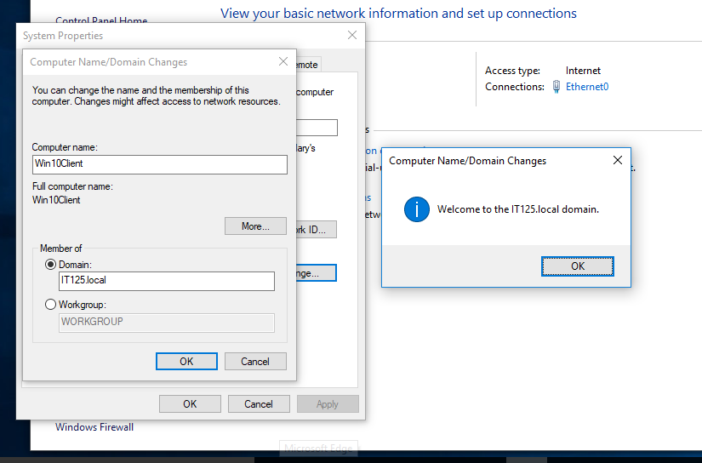
  - When the computer restarts, it will be a member of the domain!
  - Switch to the Domain Controller. Open Active Directory Users and Computers. Expand the Domain. In the Users Container, create a standard user. Be sure to use a generic password that you are comfortable sharing in this assignment, such as Password1234. Record the credentials below:
Standard Account Name | Password
Student1 | MSPress#1
  - Switch to the Windows 11 client and log into the domain with the standard account credentials. Make sure that the login screen is asking for a domain account.
  - If the login screen doesn’t reflect the domain, you will need to preface the username with the domain name. In this example, it would be:
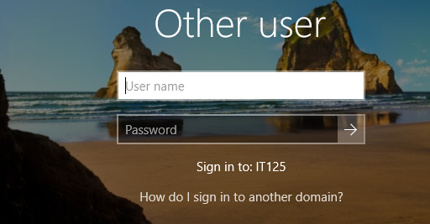
IT125\student1 (username of standard user)

- If you have any problems, please communicate with the instructor or fellow students!
- After you have successfully logged into the domain, execute any command or go to any screen that shows domain membership. You can do this with PowerShell using this command: Get-WmiObject -Namespace root\cimv2 -Class Win32_ComputerSystem | Select Name, Domain.
- Take a screenshot of the domain membership and paste it below.
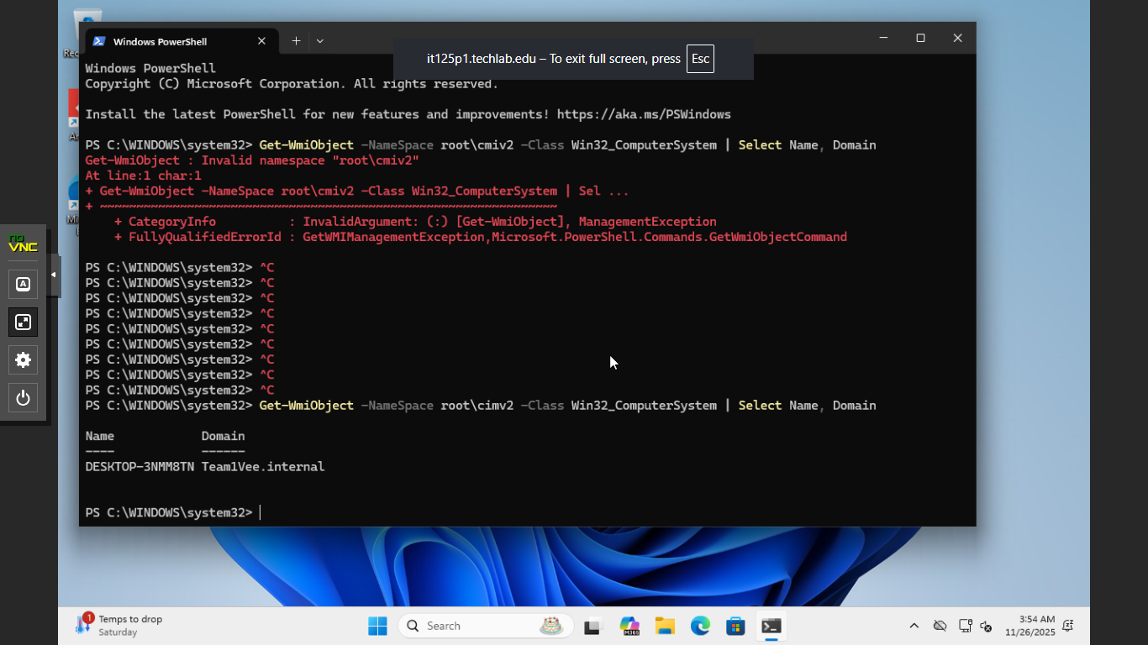
- Using Group Policy, select a wallpaper image and then create a Group Policy Object (GPO) to deploy the image to client computers. Here is a link to one site that can guide you: https://woshub.com/setting-desktop-wallpapers-background-using-group-policy/.
- When you have selected an image, take a screenshot of it and paste it below.
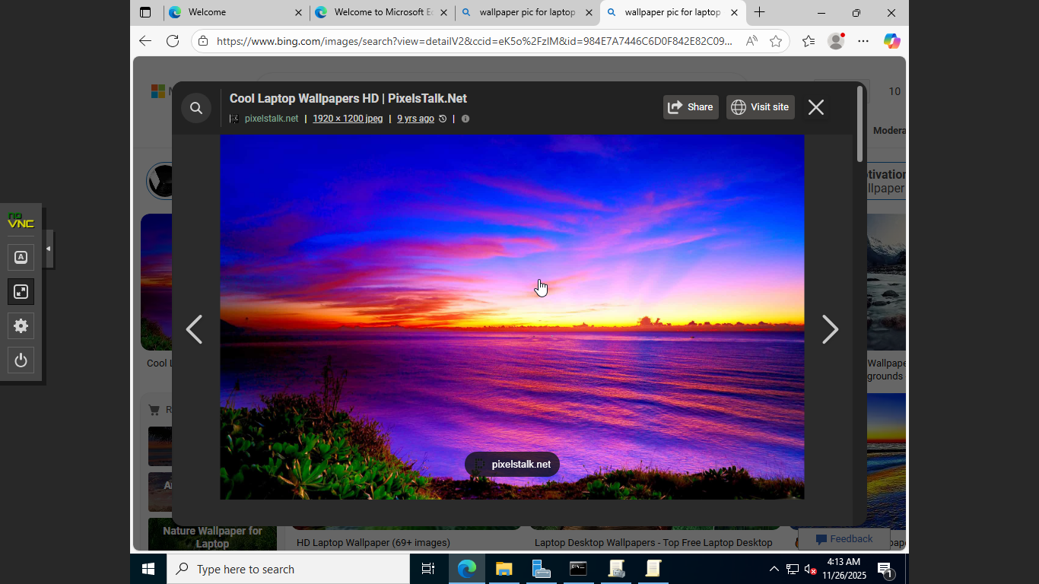
- Once you have created the GPO, take whatever additional steps are required to enforce the policy on the client.
- When the background image of your client desktop has changed to the selected wallpaper, take a screenshot of it and paste it below.
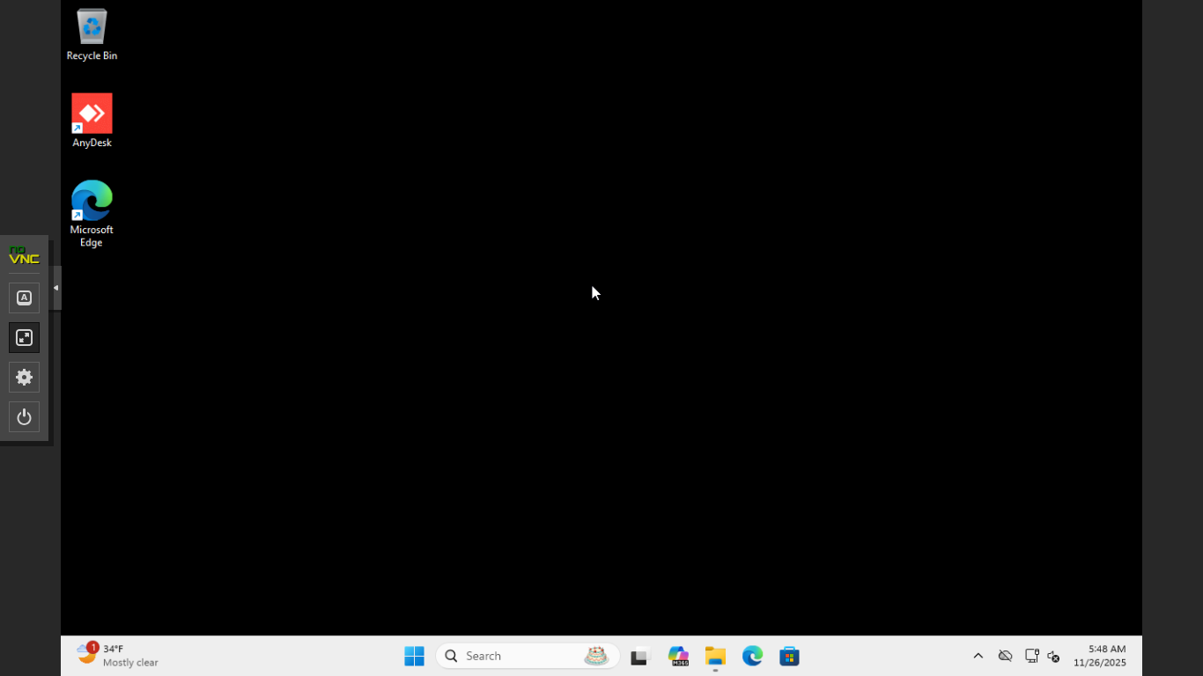

What to Submit
Check your work. You will submit this document in Canvas, which should include recording the credentials in steps 3a and 3e, as well as 3 screenshots pasted above as described in the instructions:
- Windows 11 Client Domain Membership (step 6)
- Selected wallpaper image (step 8)
- Windows 11 Client with the selected background image (step 10)

